

How to Run Bulk New Students

Prepare Upload Commands 2
Step 1 — Get Bearer Token 2
Step 2: - Prepare the Commands 2
Step 3 — Set the RTO Id 2
Step 4 — Set the Qualificaiton Id 2
Step 5 — Set the RTO State 3
Step 6 - Prepare the Student Records 3
Step 7 - Create the Employer/Organisations 3
Step 8 - Create the Supervisors 4
Step 9 - Create the Students 4
Step 10 - Update the student rto identifier 4
Attachment A - Get a Bearer Token 5
Attachment B - Open a Terminal 7

Prepare Upload Commands

Step 1 — Get Bearer Token

To run the commands you will need to get an exemplar profiling bearer token.
To do this see attachment A.

Step 2: - Prepare the Commands

Open the document Create Students and Employers in Bulk

Paste the Bearer token into Cell C1
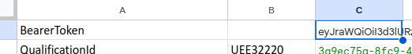

Step 3 — Set the RTO Id

In Cell B3 put the RTO/Campus name (for a list of valid RTO/Campus names. See tab RTOsVlookup)

Step 4 — Set the Qualificaiton Id

In Cell B2 put the Qualiification code. E.g. UEE30820 or UEE32220.

Cell C2 should be populated with a long id number/text.

Step 5 — Set the RTO State

Put the state of the RTO in Cell C3. e.g. SA, NSW

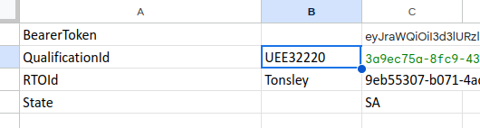
Step 6 - Prepare the Student Records

Put data into columns A… J
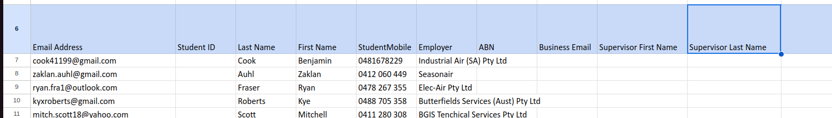

Leave the column blank if the data has not been provided.

Step 7 - Create the Employer/Organisations

For each row, select and copy the values in column L

Open a text editor and paste the values in column L.

Save as employers.sh

Open a terminal.

Run the command:
sh employers.sh

Step 8 - Create the Supervisors
For each row, select and copy the values in column M

Open a text editor and paste the values in column M.

Save as supervisors.sh

Open a terminal.

Run the command:
sh supervisors.sh

Step 9 - Create the Students
For each row, select and copy the values in column N

Open a text editor and paste the values in column N.

Save as students.sh

Open a terminal.

Run the command:
sh students.sh

Step 10 - Update the student rto identifier
For each row, select and copy the values in column O

Open a text editor and paste the values in column O.

Save as student_ids.sh

Open a terminal.

Run the command:
sh student_ids.sh

Attachment A - Get a Bearer Token

Log into Exemplar Profiling.

On the users page but any value in the first name field.

Right click. Select ‘Inspect’

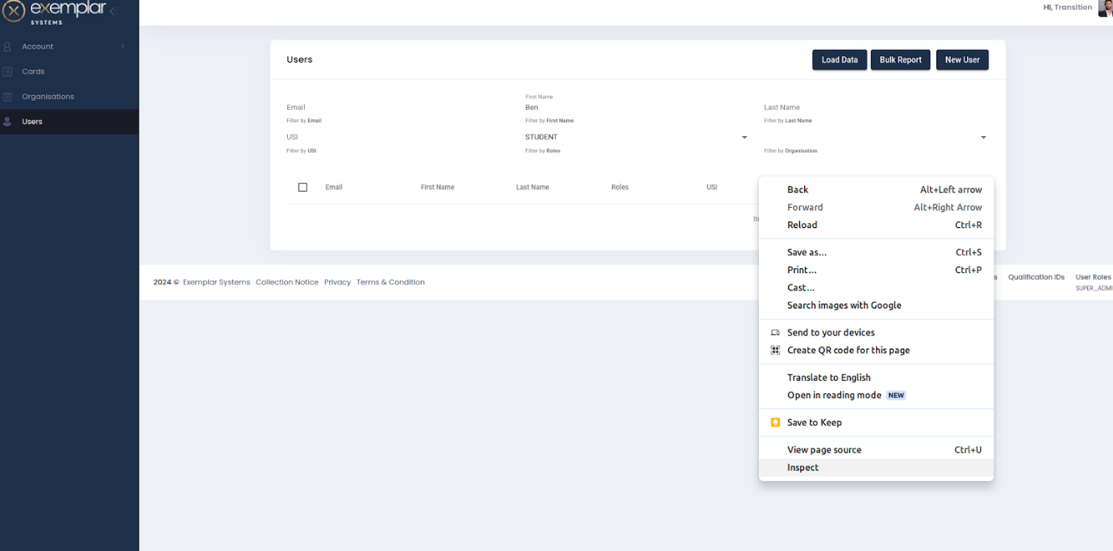

Update the view to ‘Network’

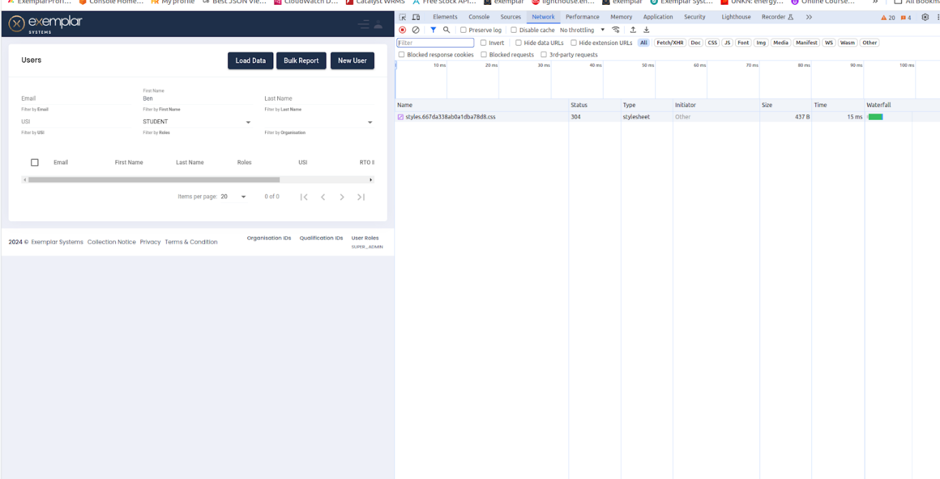

Press ‘Load Data’ and click on the /users?page line.

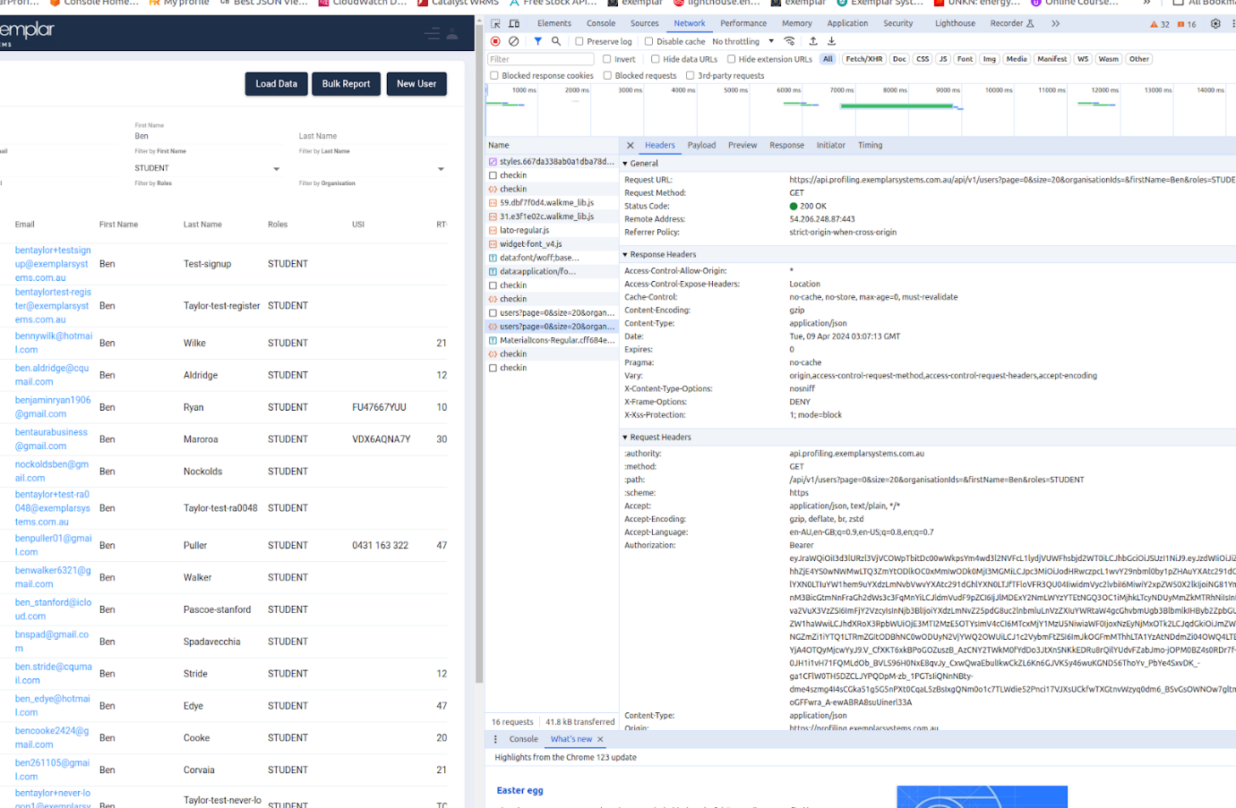

Select and copy the “Bearer” value.
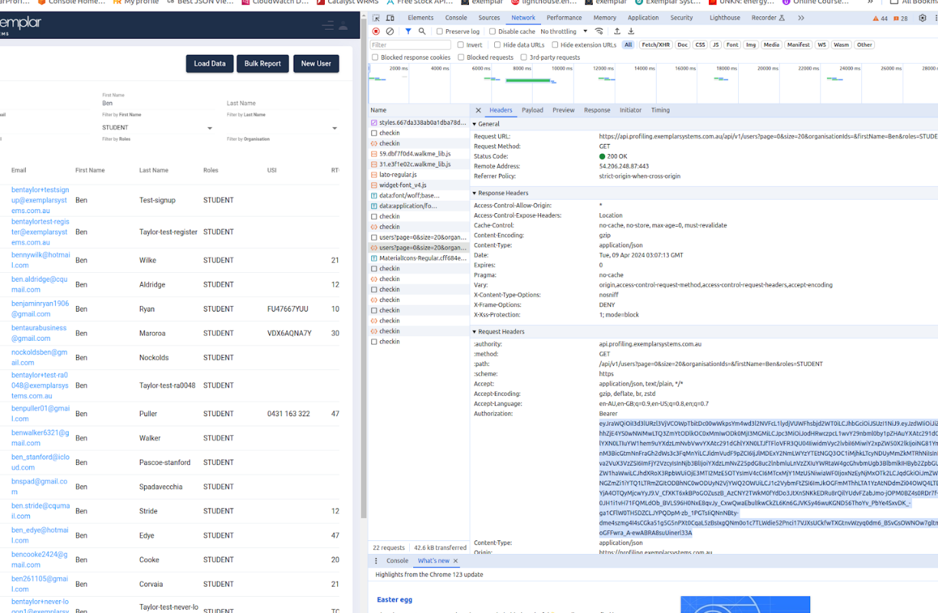

Attachment B - Open a Terminal

In windows go to:
- Select the Start Menu (the Windows icon) in the taskbar, or press the Windows key.
- Type cmd.
- Select Command Prompt from the list.
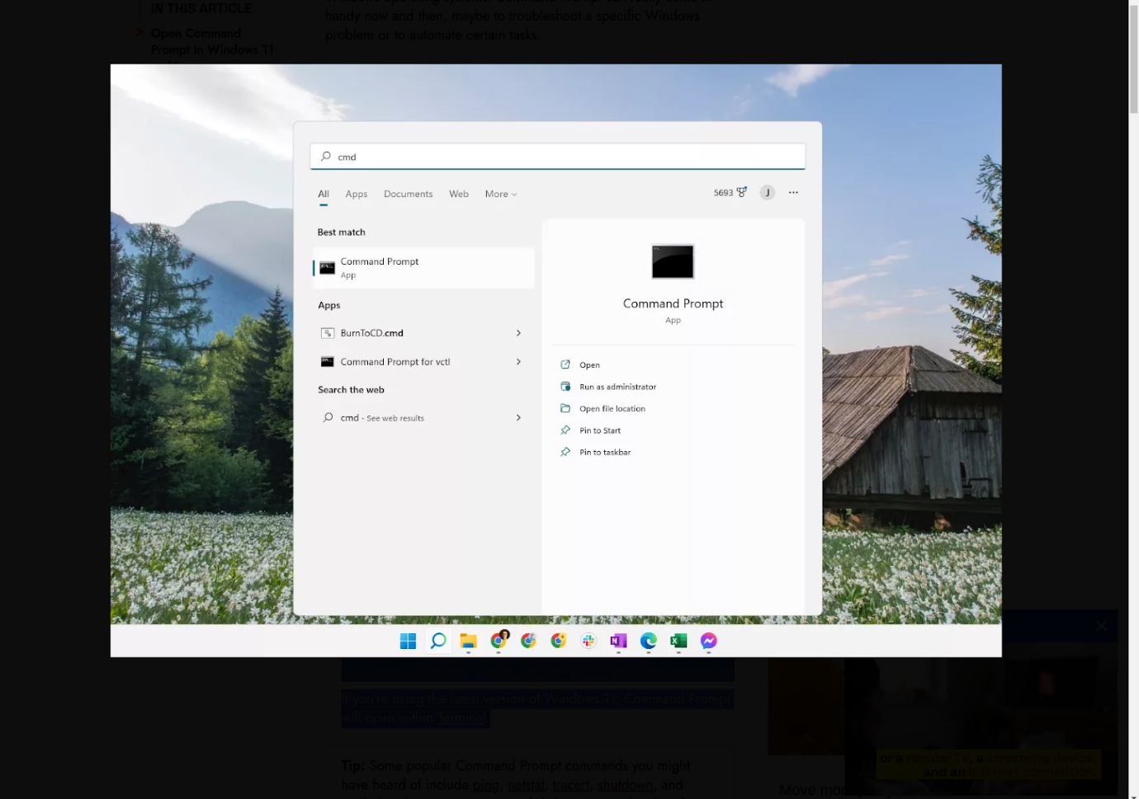
If you're using the latest version of Windows 11, Command Prompt will open within Terminal.

